Team Health Assessment

Report Builder

User Documentation

Table of Contents

**Introduction** **3**

**System Setup** **3**

**1 System Pre-Conditions** **4**

1.1 Microsoft Office Pre-Conditions 4

1.1.1 Windows Users 4

1.1.2 Mac Users 5

1.2 ‘Team Health Assessment Report Builder’ Pre-Conditions 6

1.2.1 Excel Report Template File Path 6

1.2.2 Word Report Template File Path 7

**2 Legend** **9**

2.1 Update Question List 9

2.2 Categories Legend 10

2.3 False Responses to be Flagged Legend 11

**3 Aggregate Data by Team** **12**

3.1 Steps for Windows User 12

3.1 Steps for Mac User 13

**4 Generate Team Word Report** **15**

4.1 Team Report Summary 15

4.2 General Use 15

4.3 Making Changes to Report Template 17

4.3.1 Change Report Template Body 17

4.3.2 Add Dynamic Boxes to Report Template 18

**Appendix A: Module Explantation** **19**

# 

# 

# Introduction

The purpose of this software is to utilize the ‘Team Health Assessment Builder’ to take the csv output from Qualtrics and aggregate the data into the Excel and Word reports.

This document describes the process to generate the Team Health Assessment Report and the required steps needed to properly generate the reports.

# System Setup

The files needed to aggregate the Team Health Assessment survey results and create the corresponding reports can be found on [Google Drive](https://drive.google.com/drive/folders/0B5J14KabXLP4WjNXNERFaF80Yzg). The following files can be found in the ‘Current Version of Report Builder’. The ‘Documentation’ folder contains all documentation. The ‘mods’ folder contains the text files with all the code used for building the report. The ‘Previous Versions’ folder holds old versions of the Builder file in case they are ever needed.

Team Health Assessment Report Builder.xlsm

This is a macro-enabled Excel file and is used to aid all the report generation and data aggregation. This file has three buttons ‘Update Question List’, ‘Aggregate Data by Team’ and ‘Generate Team Reports’. Each of these buttons call upon different modules within the code to perform their function. The sections below will go into detail on this.

Team Health Assessment Report.xlsx

This is a template to create the Excel report for each class. The file is blank but will be populated with each classes data separated by team and saved to a different name. This file should not be edited, removed or saved over.

Team Health Assessment Report Template.docm

This is a template to create the Word report for each team per class. The file can be edited to change formatting of the report. This file can be edited but should not be removed or saved over.

# 

# 1 System Pre-Conditions

The following are pre-conditions that must be initialized on your computer to allow for the Team Health Assessment Builder to aggregate the data and create the reports. The below sections will explain add-ins and hard-coded file paths that must be initialized. This should only be needed to be done once however the following sections outlayed the steps if anything was missed the first time.

## 1.1 Microsoft Office Pre-Conditions

Microsoft Office 2016 (Excel and Word) must be downloaded onto your computer. To see the code created in the ‘Team Health Assessment Report Builder.xlsm’ file the Developer tab must be enabled and the Microsoft Office Object Library must be selected.

### 1.1.1 Windows Users

Skip to step 3 if the Developer tab is already in your Ribbon (as highlighted in yellow)

1. In the top left corner navigate to File > Options
2. From new window, select Customize Ribbon > Main Tabs > Developer (if not already checked > OK

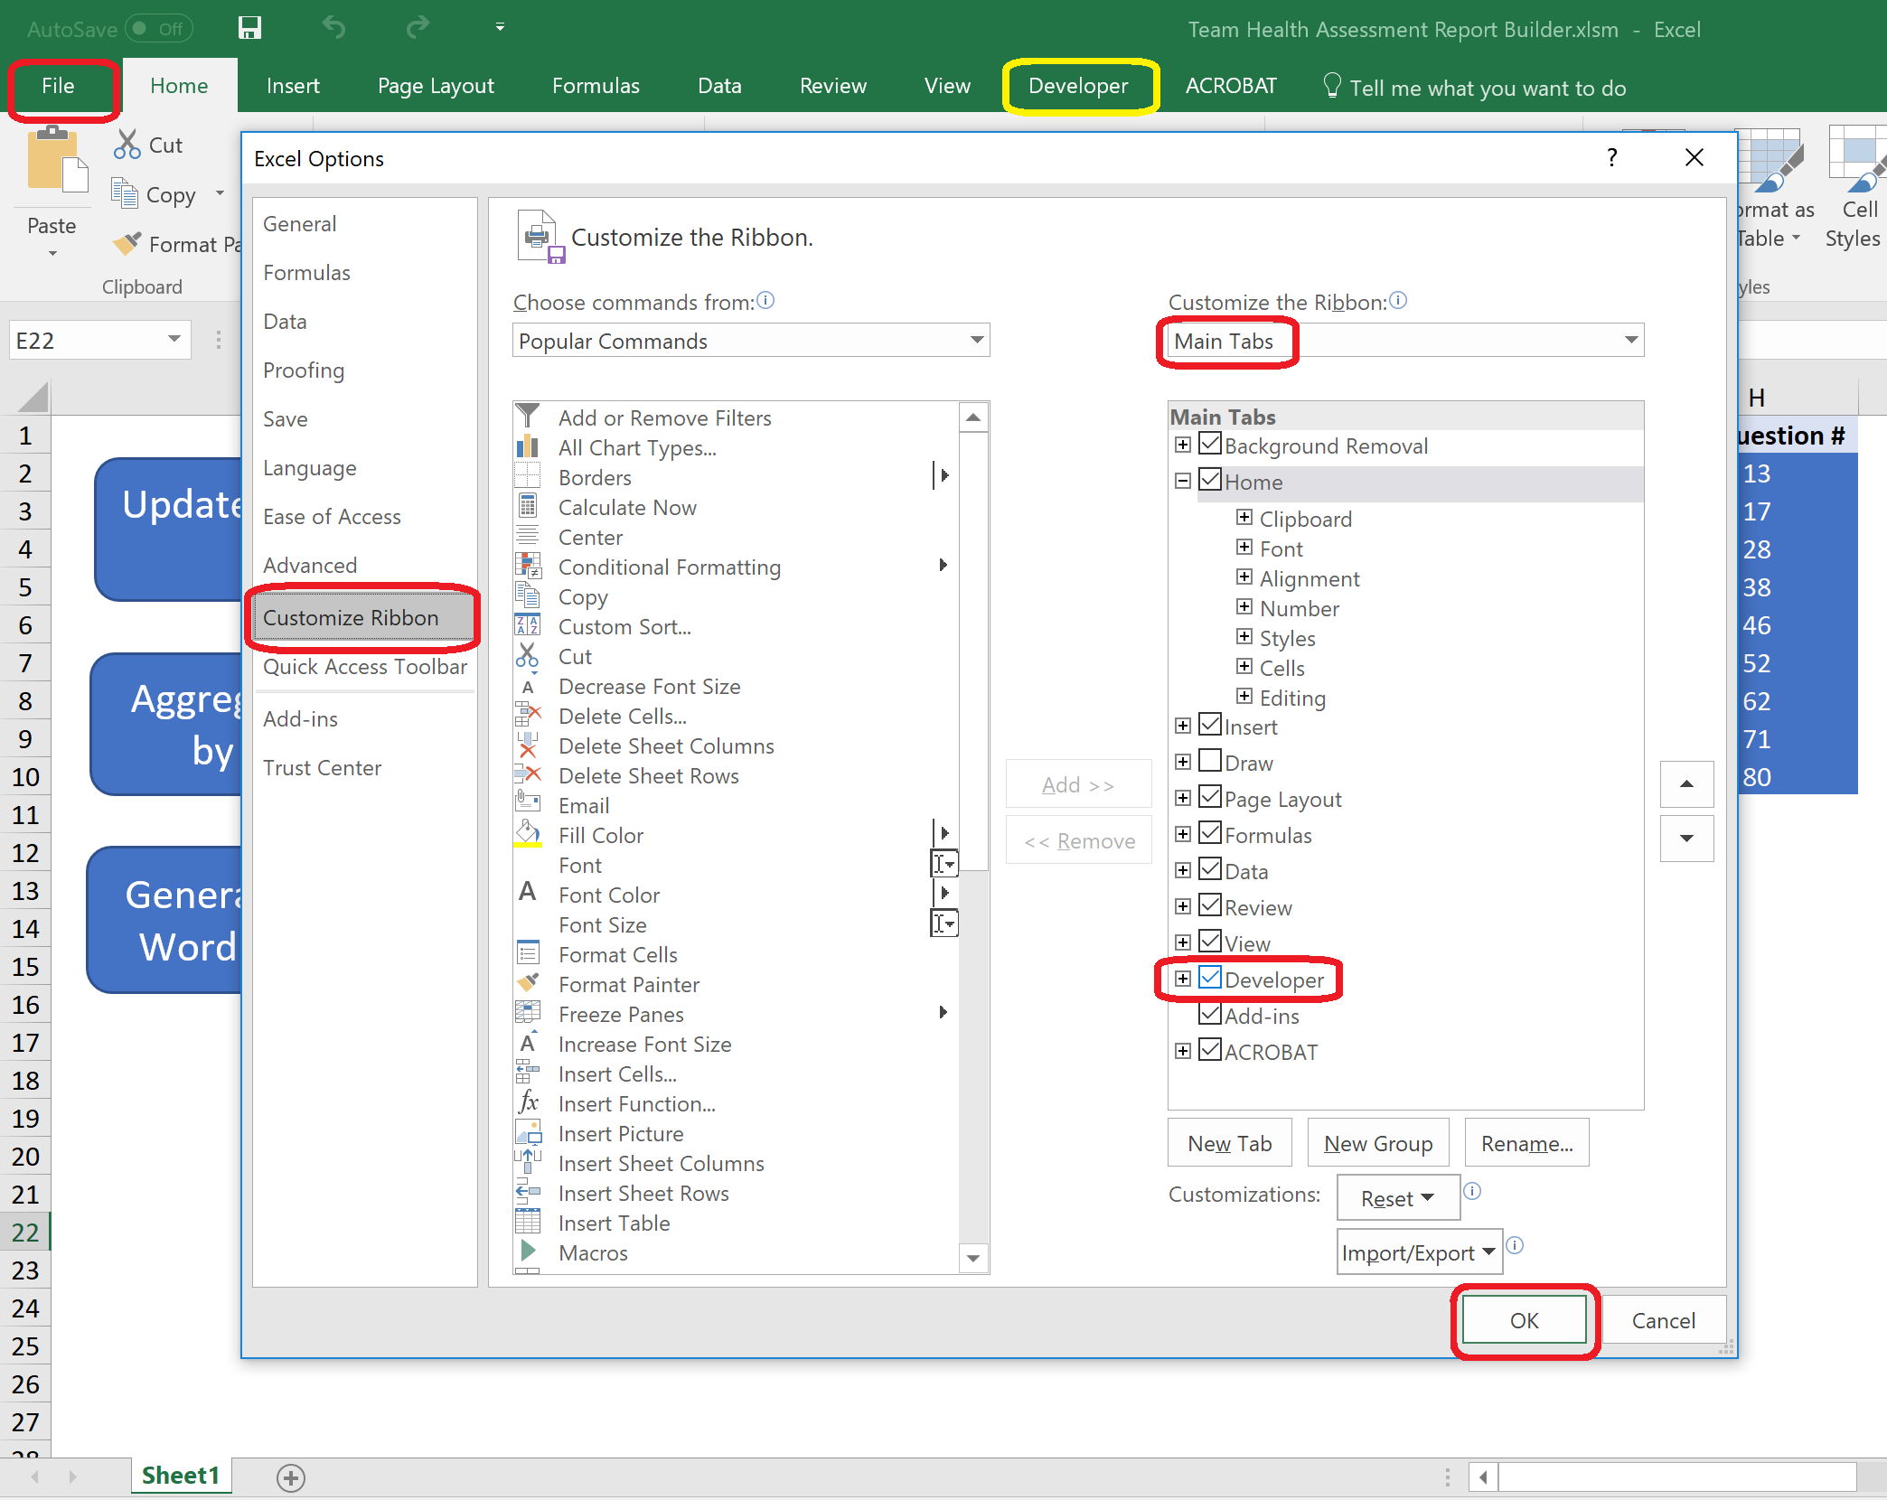

1. Navigate to Developer > Visual Basic, to open the editor

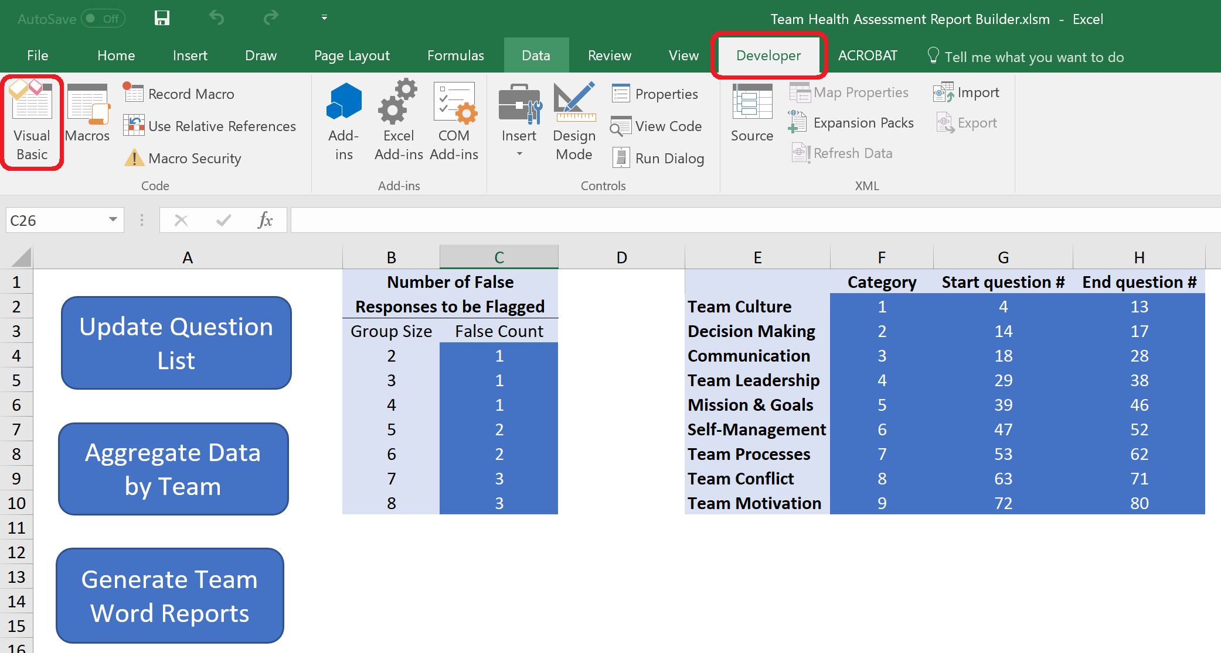

1. From new window, select Tools > References > Microsoft Office 16.0 Object Library (if not already checked) > OK

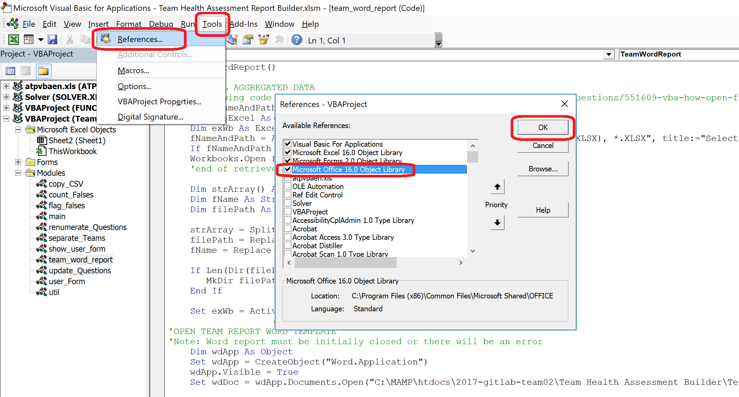

1. CTRL + S to save changes to the ‘Team Health Assessment Report Builder.xlsm’ file

### 1.1.2 Mac Users

1. In the top left corner navigate to Excel > Preferences > Ribbon & Toolbar
2. Check off the Developer in the right column if it is not already checked off

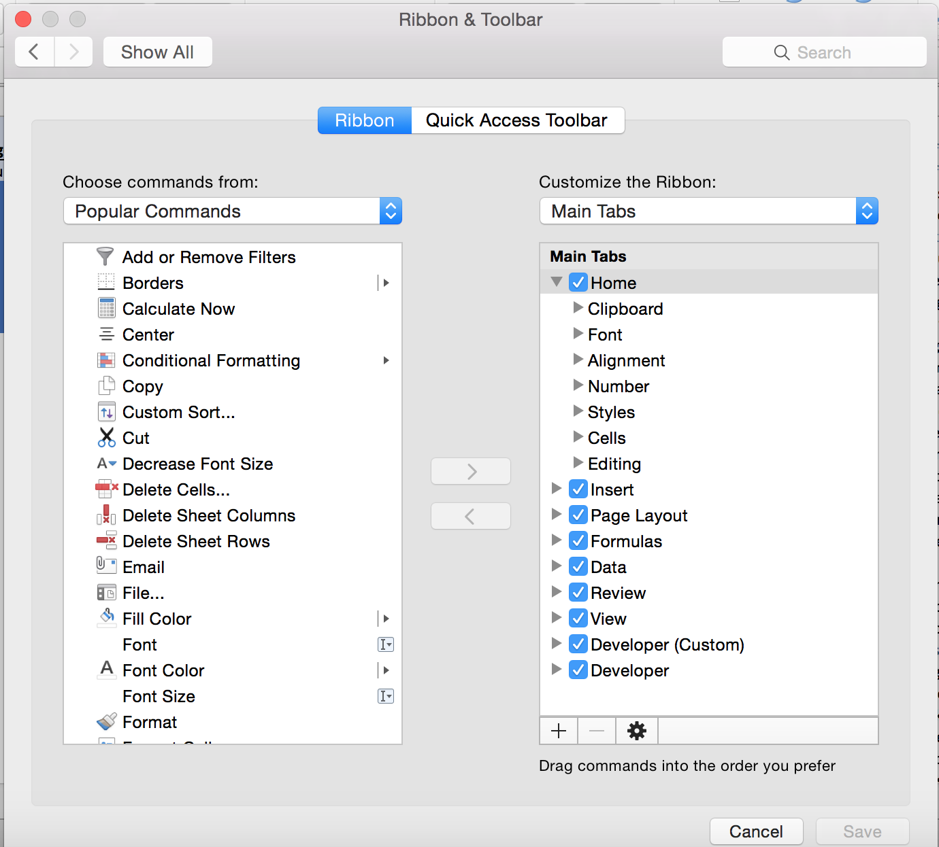

1. Press Save
2. Navigate to Developer > Visual Basic, to open the editor

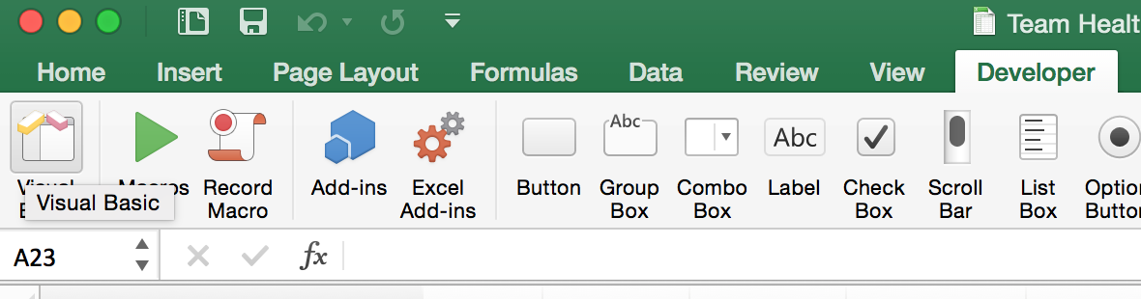

1. On the top menu of the Visual Basic editor navigate to Tools > References and ensure the ‘Microsoft Office 14.0 Object Library is checked off

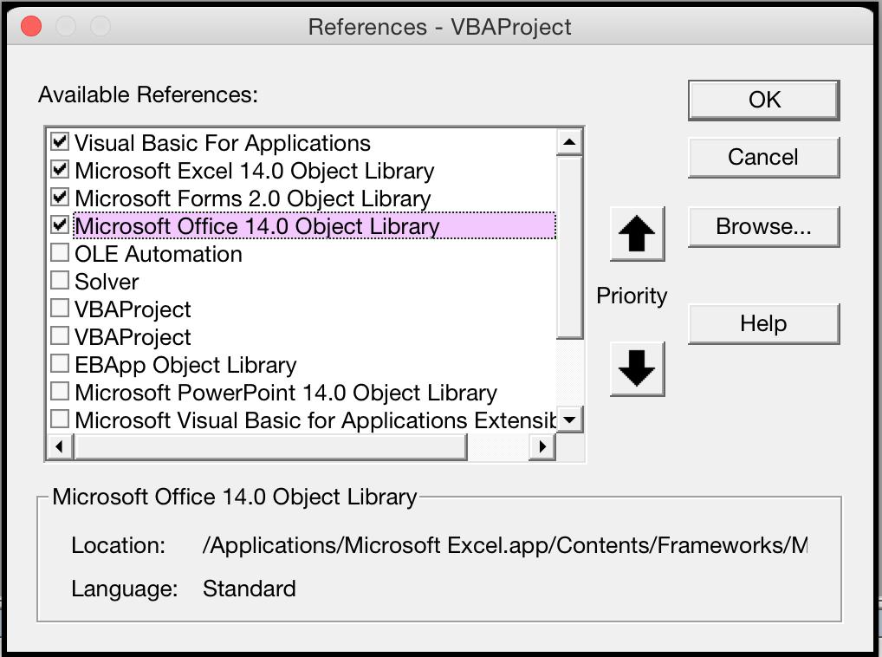

## 1.2 ‘Team Health Assessment Report Builder’ Pre-Conditions

There are two places where files are hard-coded in the module files within the code of the Team Health Assessment Report Builder. The following sections outline where to change these paths. It should be noted that these file paths should not change after the initial setup.

### 1.2.1 Excel Report Template File Path

To change the file path for the ‘Team Health Assessment Report.xslx’ the following steps should be followed to update the code. Note, following is shown on Mac OS however same steps can be followed on Windows OS.

1. From ‘Team Health Assessment Report Builder.xlsm’, select Developer > Visual Basic

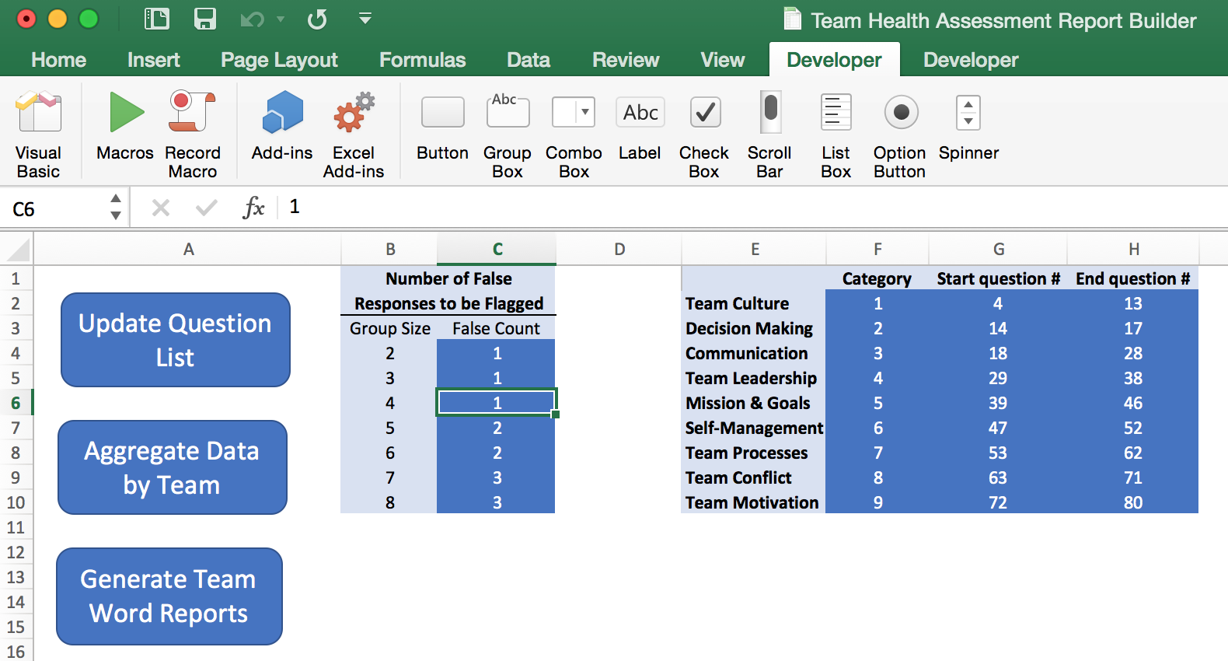

1. From the new window, select Modules > copy_CSV
2. In the code, find the green comment that says: “'The filename and file path of the Report Template for Excel must be between the quotations in the following line”. Replace the current path of the file to the path of the file on your computer in between the quotations.

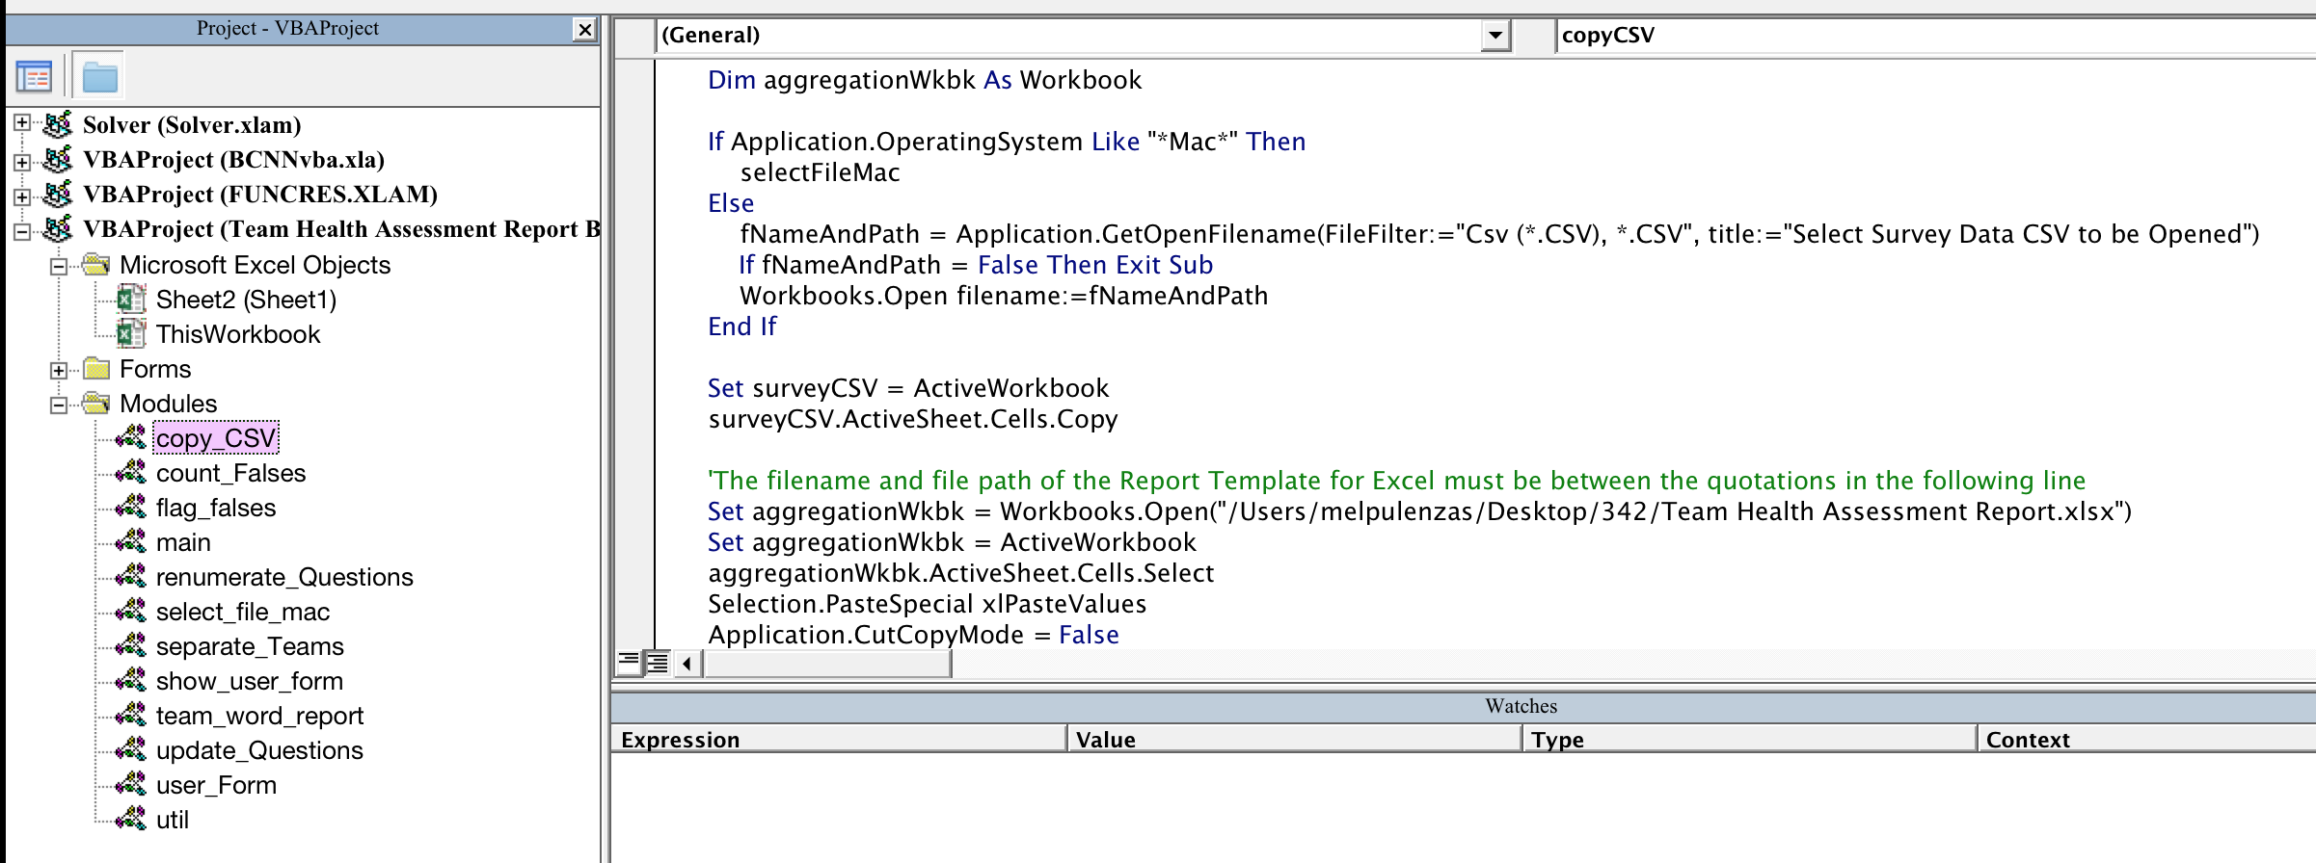

1. Press CTRL + S to save the changes.

### 1.2.2 Word Report Template File Path

To change the file path for the ‘Team Health Assessment Report Template.docm’ the following steps should be followed to update the code. Note, following is shown on Windows OS however same steps can be followed on Mac OS.

1. From ‘Team Health Assessment Report Builder.xlsm’, select Developer > Visual Basic



1. From the new window, select Modules > team_Word_Report
2. In the code, find the green comment that says: “'The filename and file path of the Report Template must be between the quotations in the following line”. Replace the current path of the file to the path of the file on your computer in between the quotations.

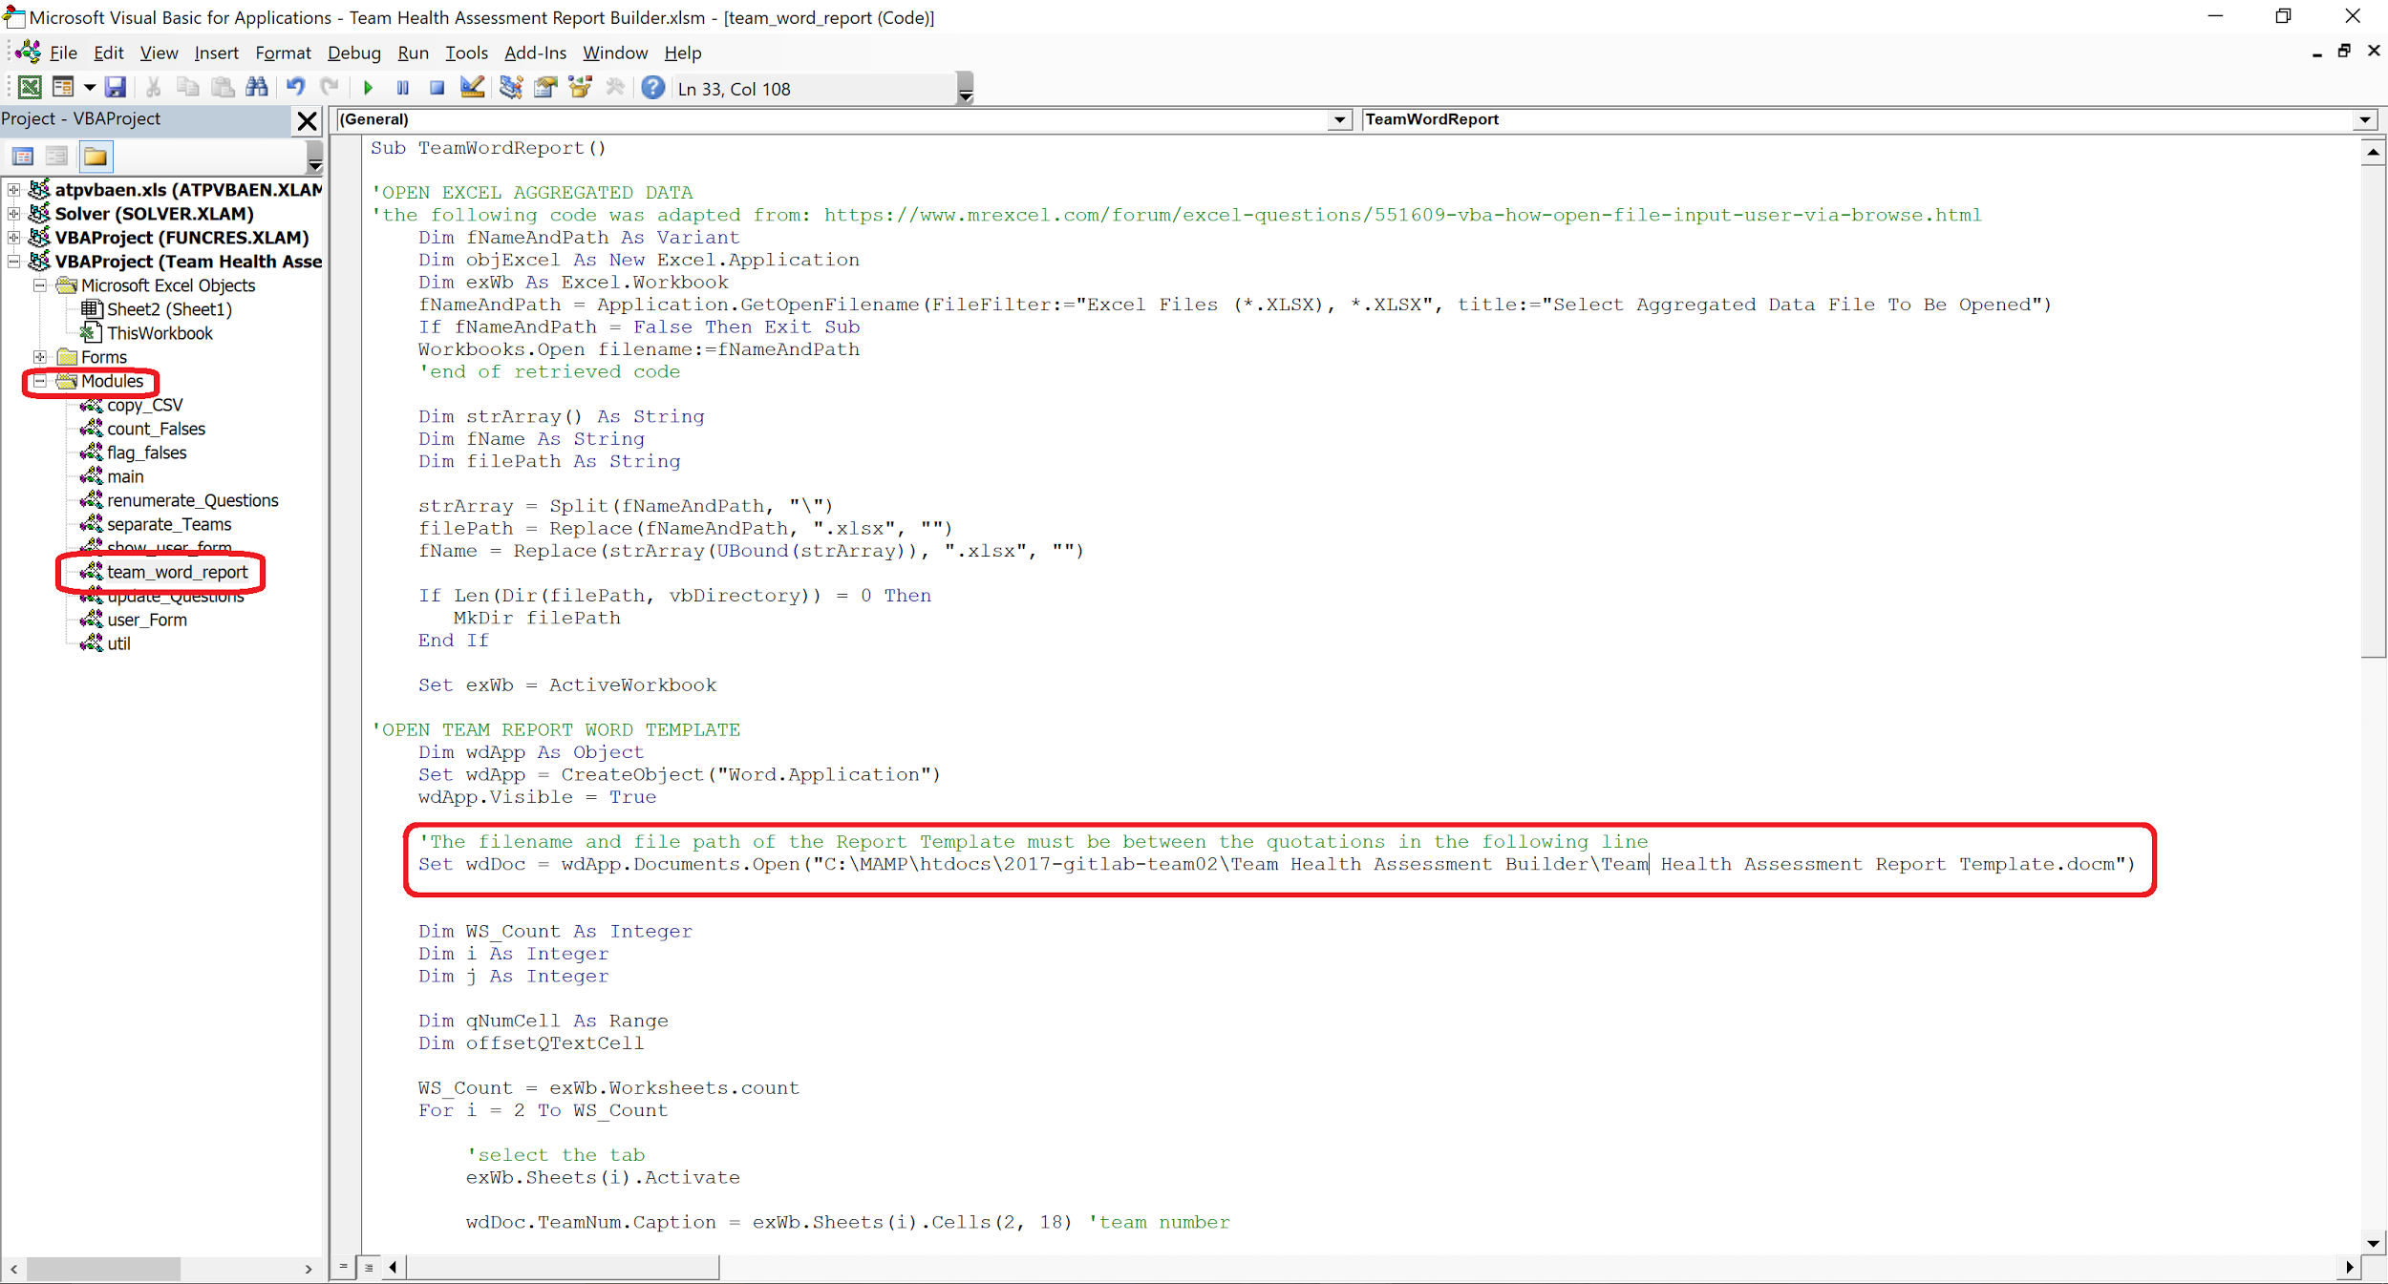

1. Press CTRL + S to save the changes.

# 

# 2 Legend

The first step in order to create the Team Health Assessment Reports is to open the ‘Team Health Assessment Builder.xlsm’. Upon opening you will be brought to the first sheet with various information explained below.

## 2.1 Update Question List

This button is to be used to update the list of questions on the Builder file. This will pull the questions from the csv file exported from qualtrics to the current sheet of the builder file. This is only used to allow the user to have the current question list visible while updating the category information (see Section 2.2). The following steps outline how to use this button.

1. Click on the ‘Update Questions List’ button at the top left corner

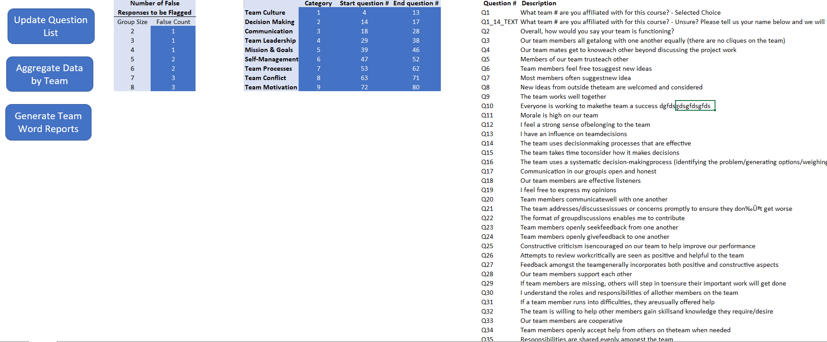

1. Select the updated export of the new survey question list and click ‘Open’. This file is the .csv survey output from Qualtrics.

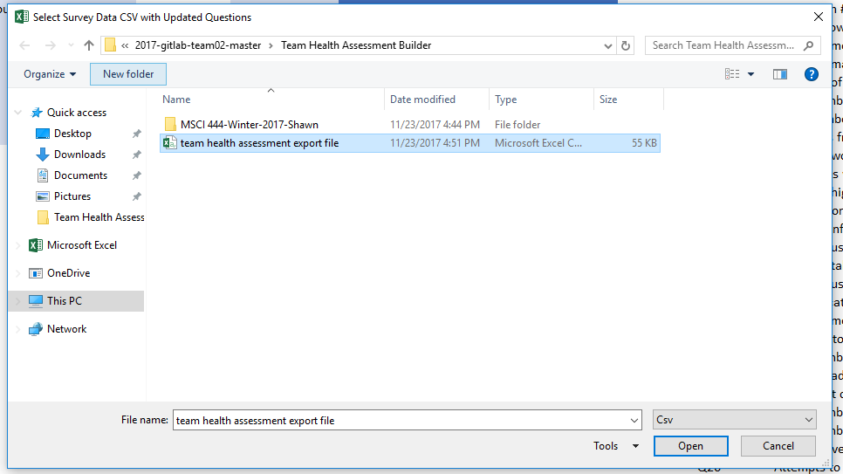

1. Then the new questions will be updated on the question list legend in the Team Health Assessment Report Builder

## 2.2 Categories Legend

The legend allows the user to specify the range of survey questions to be assessed and flagged pertaining to each category (Team Culture, Decision Making, Communication etc.). This is done by permitting the user to input the desired number of the start and end question into their respective classes as shown below.

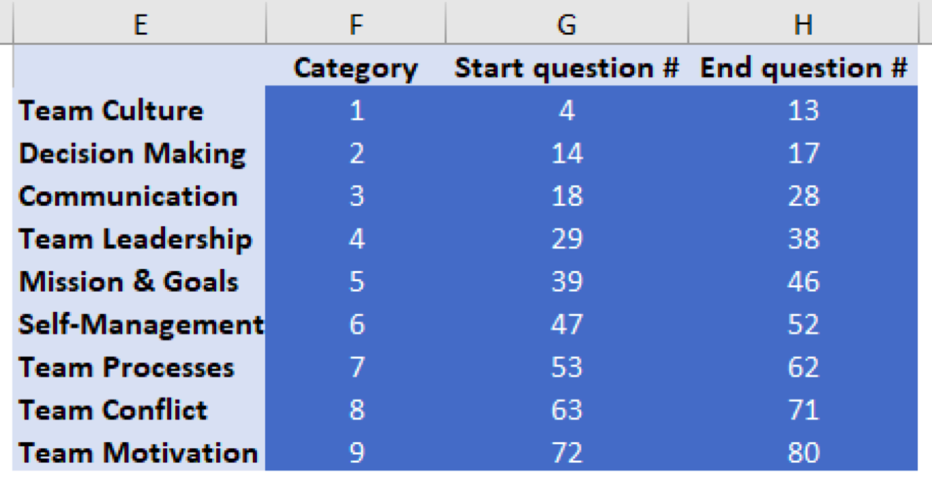

Both the *Start question #’s* and *End question #’s* can be adjusted by simply clicking on the cell that needs to be modified and entering the desired question number.

It is crucial to note that the range of the questions can be no larger than the number of T/F questions currently represented in the csv file; presently there are a total of 77 questions. If the user inputs 2 as the desired *Start question #* in Team Culture and subsequently inputs 80 as the *End question #* in Team Motivation (denoting a total of 79 T/F questions) the system will output the following error message upon clicking the ‘Aggregate Data by Team’ button.

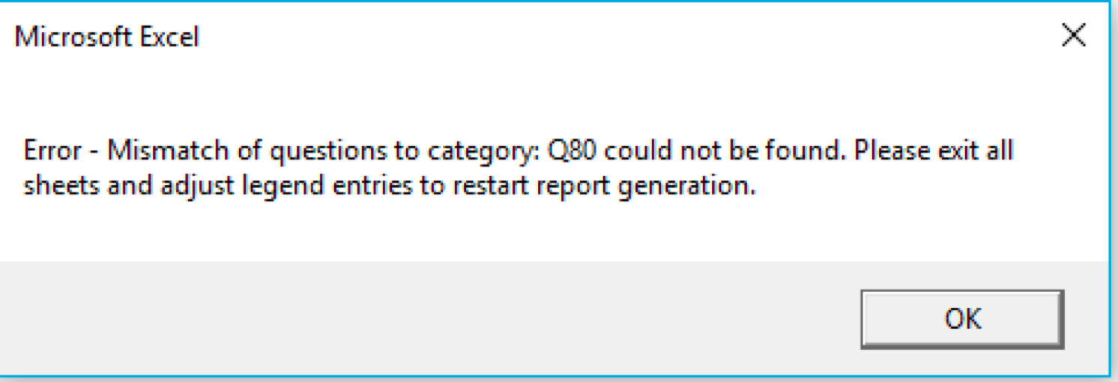

Upon clicking ‘OK’, the system will prompt the user with the following run time error:

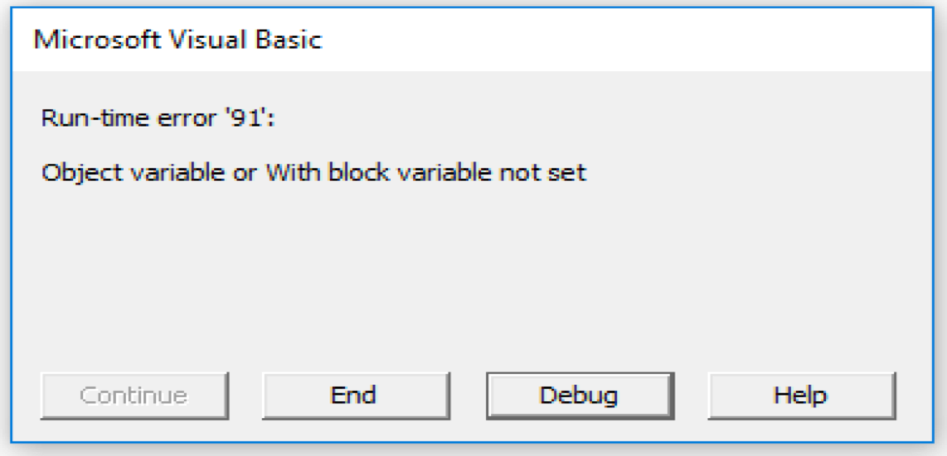

Here the user must click ‘END’. Next, the user must exit the partially completed ‘Team Health Assessment Report.xlsx’ generated by the program, make sure this file is unsaved and should go back to the legend and fix the category numbers to reference the proper questions.

It is important to remember that the program will generate the excel sheet labeled ‘Team Health Assessment Report.xlsx’ regardless of the error caused by an incorrect question range. When the error above occurs, the program will generate an incomplete version of this excel sheet. It is very crucial to exit and unsave this excel sheet before adjusting the Categories Legend to the correct question range.

## 2.3 False Responses to be Flagged Legend

This legend allows the user to specify the number of falses required to flag a certain question as being an area of concern. If the number of questions are greater than or equal to the false count for the corresponding group size than that question will be listed as an area of concern on the Health Assessment Report.

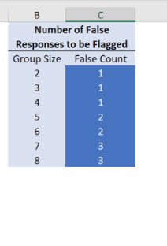

An example of this is the ‘False Count’ is set to 2 for ‘Group Size’ of 5 then the program would notify the user of an area of concern when 2 of the 5 group members answers a question with a False.

# 3 Aggregate Data by Team

The second button in the Team Health Assessment Builder is used to take the data from the csv output from Qualtrics and generates a Team Health Assessment Report Excel Spreadsheet with the class’ data. This data will be separated into different tabs for each team.

## 3.1 Steps for Windows User

The following steps outline how to use the ‘Aggregate Data by Team’ button for a Windows user.

1. After clicking the button ‘Aggregate Data by Team’, the report generation will be initialized. A file folder will open up prompting you to select a csv to generate the reports. This csv should be the direct output of the Qualtrics survey results.

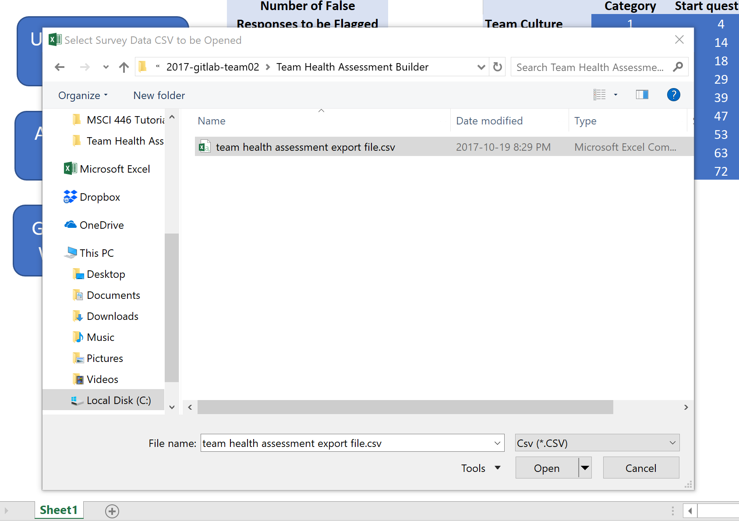

1. After the report is generated, a prompt will display to fill in the following information. The ‘Team Health Assessment Report.xlsx’ will be updated with the new team information and will need to be save. The information specified in this prompt will be used as the naming convention to save the file.

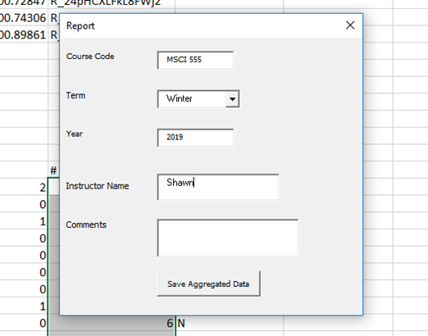

1. After filling in the user form with course code, term, year, Instructor name, comments (optional), click the button for saving aggregated data. Then another window for selecting a folder where the user wants to save the excel output file will show up.

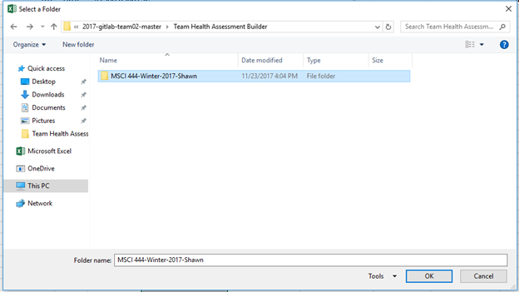

1. After selecting the targeted folder, the user needs to click ‘OK’ and the Excel output file will be saved in the selected folder. The name of the file is in the format of “Course Code-Term-Year-Instructor Name-Comment (optional)”



## 3.1 Steps for Mac User

The following steps outline how to use the ‘Aggregate Data by Team’ button for a Mac user.

1. After clicking the button ‘Aggregating Data by Team’, the report generation will be initialized. A file folder will open up prompting you to select a csv to generate the reports. This csv should be the direct output of the Qualtrics survey results.

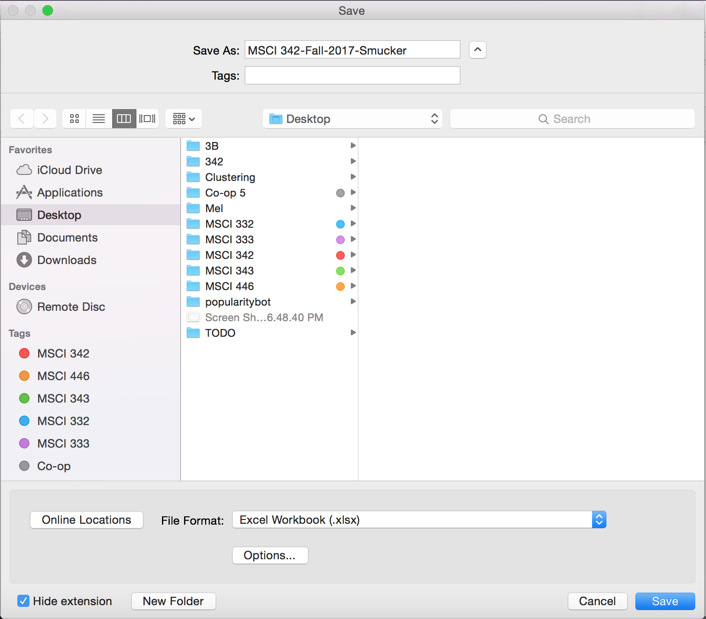

1. The Excel report will be generated and a window will appear to select the file location and to enter a filename to save the report. To keep with consistency of the Windows method above the name should be in the form ‘Course Code-Term-Year-Instructor Name-Comment (optional)’.

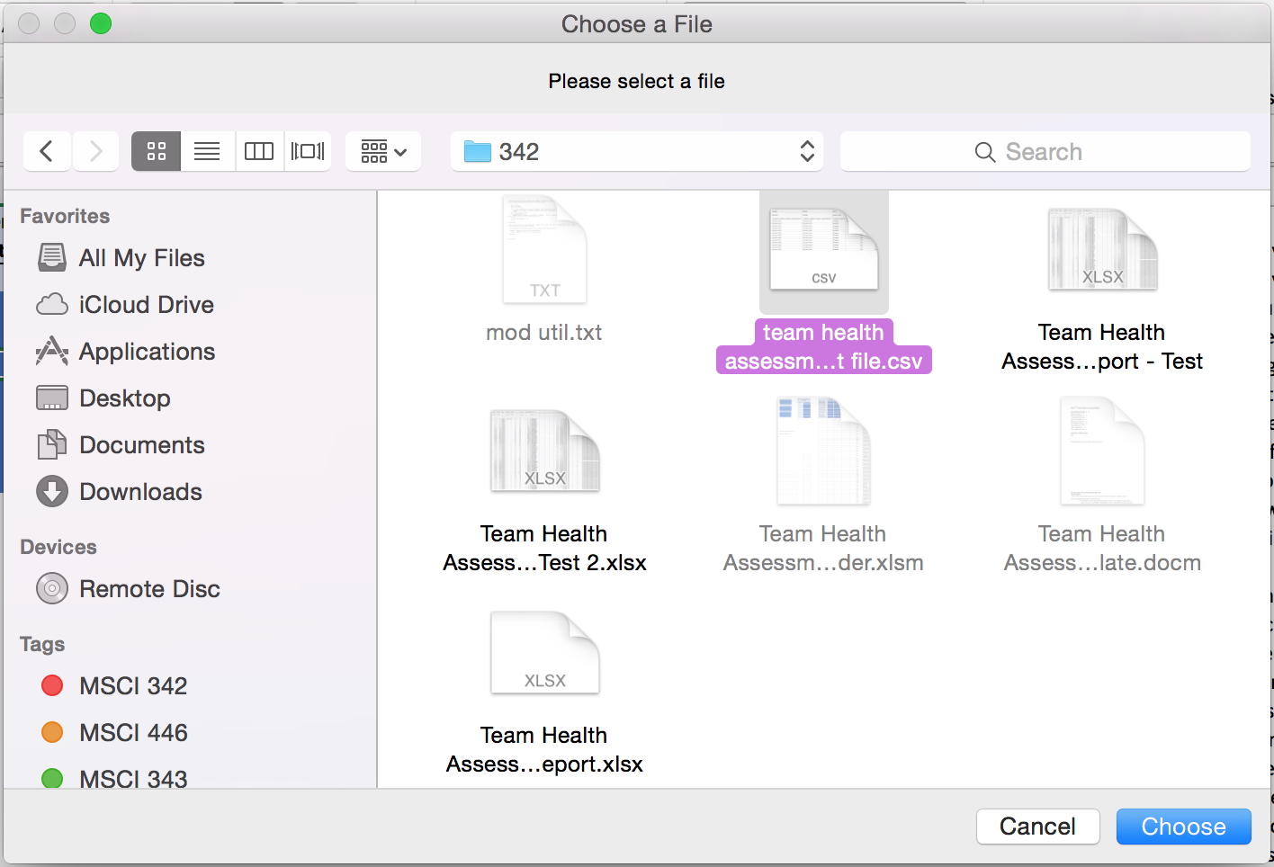

# 4 Generate Team Word Report

## 4.1 Team Report Summary

The purpose of the third button *Generate Team Word Reports* on the *Team Health Assessment Report Builder* is to generate and save a report for each team within a project, by accepting as input the Excel file with the aggregated data by team for that project (see *Aggregate Data by Team*). Each team report contains the following information:

* Team number
* Overall team total (calculated as the percentage of “True” responses for the entire survey)
* Team health for each category (calculated as the percentage of “True” responses for the respective category)
* List of question numbers with variance (survey questions for which the number of “False” responses met the minimum criteria to be flagged)
* List of corresponding survey questions with variance
* Descriptions of each category

## 4.2 General Use

**Note:** Before pressing the Generate Team Word Reports button, please ensure that there are no previously generated team reports open.

**Note:** If you receive an error message at any point during the process, select ‘End’ (not ‘Debug’), close the report template (if open) and the aggregated data Excel file (if open) and **do not** save changes.

1. From ‘Team Health Assessment Report Builder.xlsm’, press the Generate Team Word Reports button. A Open File Dialog Box will appear.
2. Select the desired Excel file (.xlsx) that contains the aggregated team data that was previously generated using the second button (see *Aggregate Data by Team*).

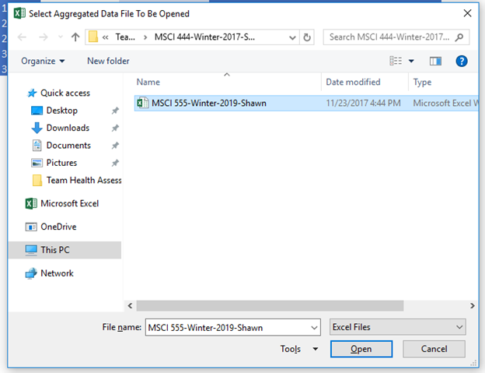

1. A report is being generated and saved for each team from the aggregated data Excel file. This process may take a few seconds to complete.
2. Once complete, a message box will appear on ‘Team Health Assessment Report Builder.xlsm’. Click OK to close the message.
3. To view the generated reports, use your computer’s File Explorer to navigate to the location of the inputted aggregated data Excel file from Step 2. You will find a folder with the same name as the Excel file. Inside this folder is the generated report for each team.

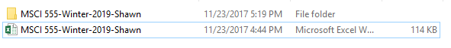

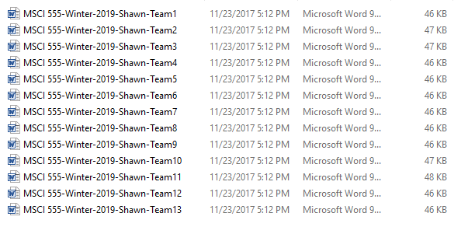

## 

## 

## 4.3 Making Changes to Report Template

### 4.3.1 Change Report Template Body

The Team Health Assessment Report Template.docm can be edited in MS Word as a normal document, with the exception of the dynamic boxes (outlined in red below).

Dynamic boxes are boxes that are populated with values from the Excel aggregated data file. The first ‘XX’ will be replaced by the team’s number, and the rest of the ‘XX’’s will be replaced by the team’s percentage for the corresponding category. Also, ‘QX’ and the large box below it will be replaced by the questions with variance. If you need to adjust the size of these dynamic boxes, you can do so by selecting Developer > Design Mode (outlined in yellow below).

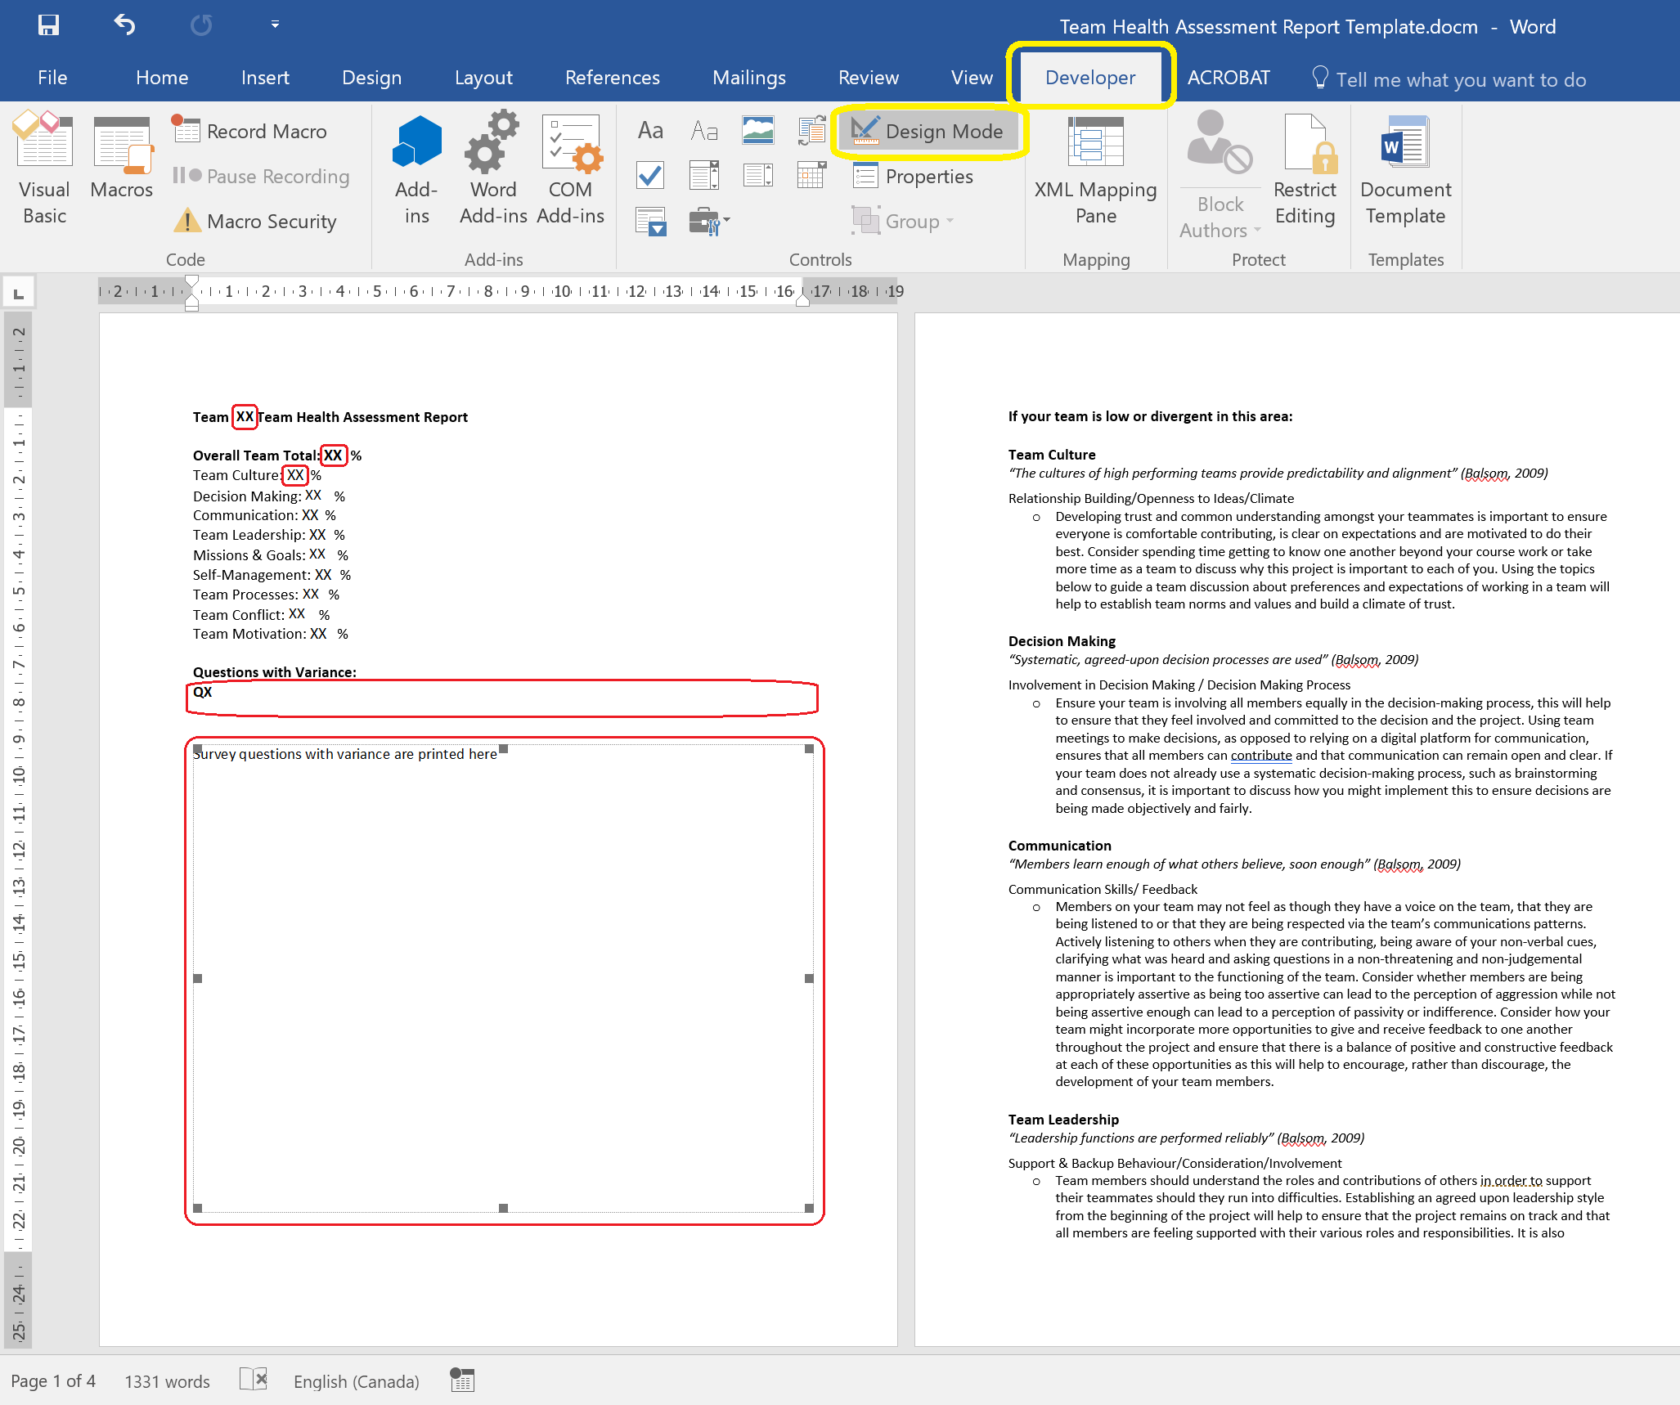

### 

### 

### 4.3.2 Add Dynamic Boxes to Report Template

For step-by-step instructions on adding dynamic boxes in the Word report template to which Excel values can be passed, please see [How to Integrate Excel Data Into a Word Document](http://www.makeuseof.com/tag/integrate-excel-data-word-document/).

This may need to be completed if changes are made to the number of categories in the Team Health Assessment survey. After creating dynamic boxes in the Report Template (see section “Setting Up the Word Document” in link above), navigate to the team_word_report module in the Team Health Assessment Report Builder (see 4.4.2 for navigation instructions). From this module, find the green comment that says: “'Pass Excel values to dynamic boxes in Word Report Template” and follow instructions from “Prepare the Excel Data Import” in link above. The general code is as follows:

wdDoc.InsertLabel.Caption = exWb.Sheets(i).Cells(R#, C#)

Replace “InsertLabel” with the label name of the box you want to populate from the Report Template. Replace “R#” and “C#” with the row number and column number of the desired Excel value from a team’s aggregated data file (likely the row and column number of the % of Trues for a given category).

# Appendix A: Module Explantation

The following chart will outline in high level terms what the main functionality of each of the module is for in the ‘Team Health Assessment Report Builder.xslm’.

|  |  |
| --- | --- |
| **Module Name** | **Explanation** |
| copy_CSV | Copies the csv given by the user to the first tab on ‘Team Health Assessment Report.xlsx’ |
| count_Falses | Counts the false responses per question for each of the teams. |
| flag_Falses | Flags the questions that are greater than or equal to the false threshold defined by the user in the legend per team on the ‘Team Health Assessment Report Builder.xlsm’ |
| main | Calls copy_CSV, renumerate_Questions, separate_Teams, count_Falses, flag_Falses and show_User_Form for the ‘Aggregate Data by Team Button’ |
| renumerate_Questions | Remunerates the question numbers |
| select_File_Mac | Code for a Mac to be able to select a file from their computer. Called every time a user is prompted to select a file when using a Mac operating system. |
| seperate_Teams | Separates the data from the csv output to the Excel report by team. |
| show_User_Form | Shows the user form to save the Excel report. Only called when the user is using a Window operating system. |
| team_Word_Report | Take the Excel report as an input from the user and outputs a Word Report for each team. |
| update_Questions | Updates the list of questions from the inputted csv from the user onto the legend sheet of the ‘Team Health Assessment Report Builder.xlsm’ |
| user_Form | Contains the actual user form to prompt the user for information to save the Excel report. |